
SCSJ3323: Software Design and Architecture

Software Design Document

DeepCells - Cancer Prediction System

Version 1.0

06/06/2022

Malaysia-Japan Int’l Institute of Technology

Department of Software Engineering

Prepared by: Ruhul Quddus Tamim

Revision Page
- Overview
The current version of the document describes the introduction and specific requirements of the system. The scope, definition, reference, purpose, acronyms, abbreviation and overview of the system are included in the introduction. External interface requirements, system features (including use case diagram, domain model, state machine diagram, activity diagram, sequence diagram and use case specification), performance requirements, design constraints, software system attributes and other requirements of the system are included in specific requirements.

- Target Audience
Doctors and Patients.

- Project Team Members
List the team members and respective assigned module.

- Version Control History
Version | Primary Author(s) | Description of Version | Date Completed
Version 1.0 | Ruhul Quddus Tamim | Combined SRS, SDD, STD as SD

Note:
This template is an annotated outline for a software design document adapted from the IEEE Recommended Practice for Software Design Descriptions. The IEEE Recommended Practice for Software Design Descriptions have been reduced in order to simplify this assignment while still retaining the main components and providing a general idea of a project definition report. Please refer to IEEE Std 10161998 1 for the full IEEE Recommended Practice for Software Design Descriptions. Examples of models are from Satzinger (2011). Compiled by Shahliza Abdul Halim, PhD and checked by Shahida Sulaiman, PhD on 2 May 2016.

Table of Contents
1.0 Introduction 1
1.1 Purpose 1
1.2 Scope 1
1.3 Definitions, Acronyms and Abbreviation 2
1.4 Reference Materials 2
1.5 System Overview 2
2.0 System Architectural Design 2
2.1 Architectural Style and Rationale 2
2.2 Architecture Model 4
2.3 Use Case Diagram 5
3.0 Detailed Description of Components 6
3.1 Complete Package Diagram 6
3.2 Modules Detailed Description 7
3.2.1 Subsystem <Manage Admin Module> 8
3.2.1.1 P001: Package <Cancer prediction system> 8
3.2.1.2 Class Diagram 9
3.2.1.3 Sequence Diagrams 21
a) SD001: Sequence diagram for Adding a doctor 21
b) SD002: Sequence diagram for Add Training Data 22
c) SD003: Sequence diagram for View Feedback 23
d) SD004: Sequence diagram for View Doctor Details 24
e) SD005: Sequence diagram for View Training Data 25
f) SD006: Sequence diagram for View User Details 26
4.0 Data Design 26
4.1 Data Description 26
4.2 Data Dictionary 27
5.0 User Interface Design 33
5.1 Overview of User Interface 33
5.2 Screen Images 33
6.0 Requirements Matrix 37
7.0 Appendices 38

1.0 Introduction

1.1 Purpose
This SDD describes the Cancer Prediction System which is to make a new version of the current system that cannot work, for example like, some hospitals use decision support systems, but they are largely limited. They can answer simple queries like “What is the average age of patients who have cancer disease?”, “How many surgeries had resulted in hospital stays longer than 10 days?”, “Identify the female patients who are single, above 30 years old, and who have been treated for cancer.” However, they cannot answer complex queries like “Identify the important Preoperative predictors that increase the length of hospital stay”, “Given patient records on cancer, should treatment include chemotherapy alone, radiation alone, or both chemotherapy and radiation?”, and “Given patient records, predict the probability of patients getting a cancer disease”.

1.2 Scope
The software product is DeepCells – Cancer Detection System. Generally, this system will allow the users to input necessary details and see the type of cancer predicted at an early stage.

What the system can do:

- Allows the admin to login and view or add training data for the algorithm to analyze and predict results.
- Allows the admin to add or view specialist details with respect to types of cancer.

- Allows the admin to view all the registered users’ details and their feedback.

- Allows the user to register with their basic details and predict cancer by inputting all the necessary details and the system will accordingly view doctor to consult.

- Allow the user to view various doctor based on the predicted cancer.

What the system cannot do:

- The system cannot let the patient view the training data.
- The system cannot let the patient view other patient’s profile.

The objective and goals of this system are to upgrade the current problem scenario in the system and design the system which meets the administrative, organizational, and management requirements of hospital. In addition, CPS also allows the users to access the system anytime, anywhere with the internet connection.

1.3 Definitions, Acronyms and Abbreviation
Definitions of all terms, acronyms and abbreviation used are defined as follow:
SD - System Development
CPS – Cancer Prediction System

1.4 Reference Materials
N/A

1.5 System Overview
The flow of the ERS operations are determined and represented by an as-is swim-lane diagram. After clarifying with the current problem and processes, the to-be system is proposed in a separate swim-lane diagram.

2.0 System Architectural Design

2.1 Architectural Style and Rationale
The chosen architectural design pattern is model view controller (MVC). The main reason that cause to choose this model is due to the system has multiple ways to view and interact with data and the future requirements for interaction and presentation of data are unknown. MVC is an acronym for model, view and controller and it is a product development architecture. By using MVC, it could create application that separate the different aspects of the application. Since MVC allows the data to change independently of its representation and vice versa, it enables to focus on one aspect of the implementation at a time. For example, it can focus on the controller(input logic) without depending on models and views (business logic and UI logic). By using MVC it allows to modify the system easily and multiple developers can work simultaneously on the model, controller and views.

2.2 Architecture Model

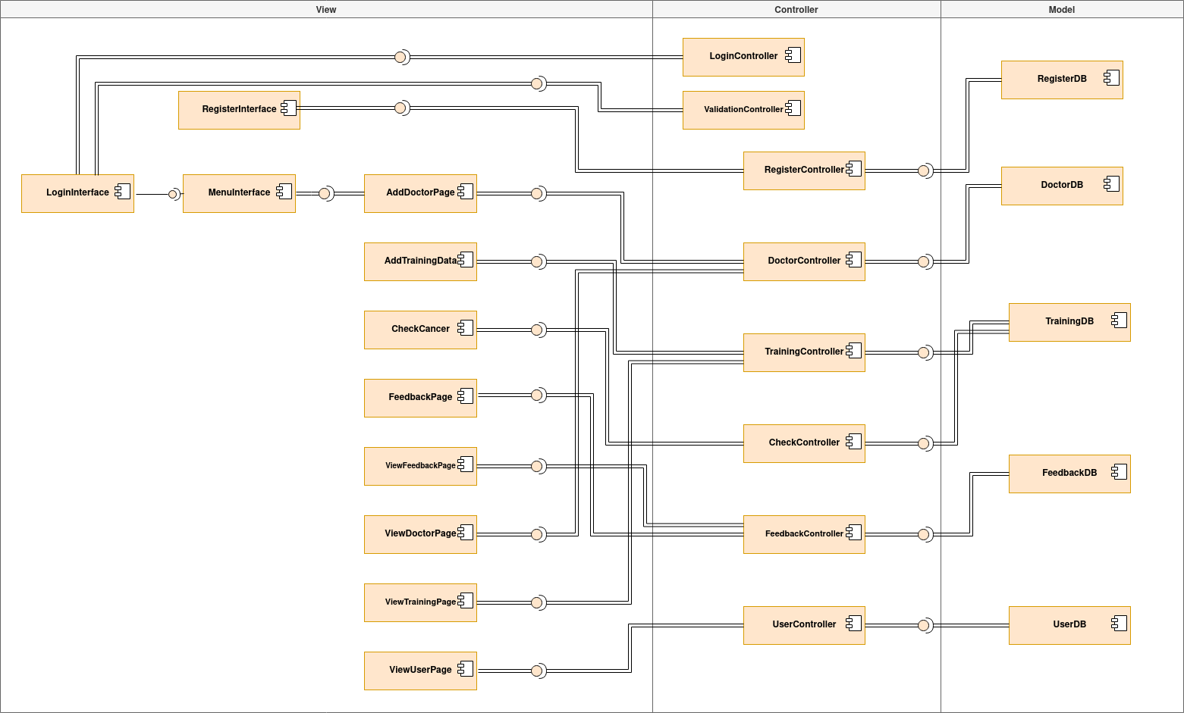
Figure 2.1: Component Model of <Cancer Prediction System>

2.3 Use Case Diagram

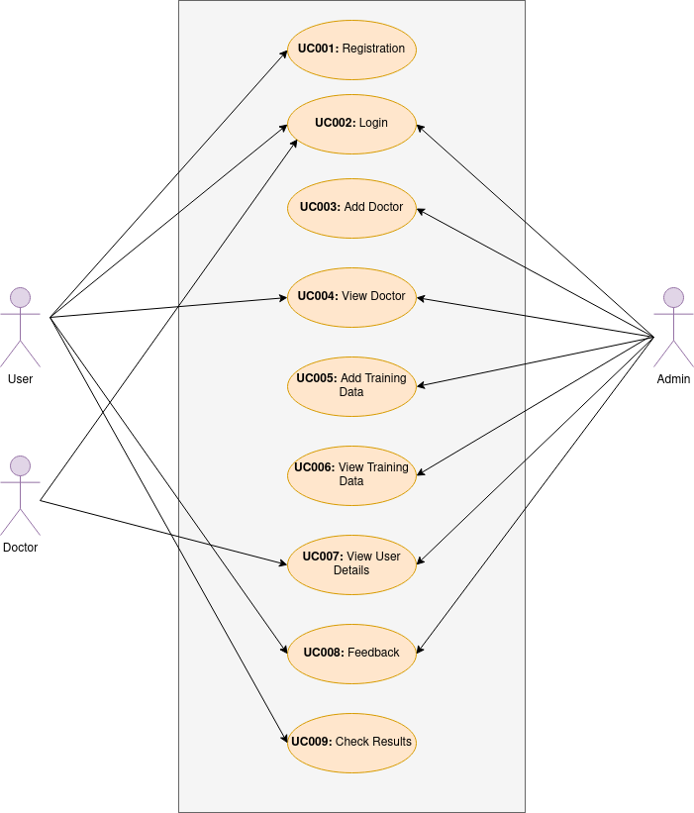
Figure 2.2: Use Case Diagram of <Cancer Prediction System>

3.0 Detailed Description of Components

3.1 Complete Package Diagram

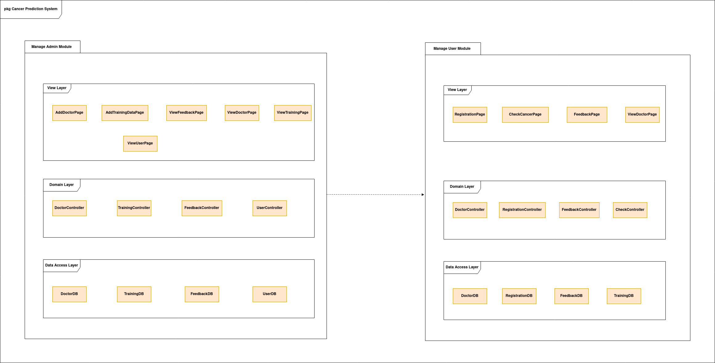Figure 3.1: Complete Package Diagram

3.2 Modules Detailed Description
The proposed Cancer prediction system consists of two subsystems that are manage admin module subsystem, and manage user module subsystem. Every subsystem consists of the view layer, domain layer, and the data access layer. The view layer is a layer that allows the user to interact with the system. The domain layer includes controller classes that related to the main function and logic of the subsystem. The data access layer is a layer that accessing the data from the database.
In Manage Admin Module subsystem(P001), it involves UC003 Add Doctor, UC004 View Doctor, UC005 Add Training Data, UC006 View Training Data, UC007 View User Details and UC008 Feedback. The subsystem provides function for the admin. In the subsystem, it has Menu-interface that interact with AddDoctorPage, AddTrainingPage, ViewFeedbackPage, ViewTrainingPage and ViewUserPage. When a admin chooses function, he/she wishes in the Menu-Interface, the related page will be displayed. In the domain layer, the subsystem consists of DoctorController, TrainingController, FeebackController and UserController. Each of the controllers related to its perspective entity in the data access layer. For example, if the admin wishes to get the list of all training data or a list of all registered users, the UserController and the TrainingController will be the handler of this tasks and retrieve the data from the UserDB and TrainingDB.

3.2.1 Subsystem <Manage Admin Module>

3.2.1.1 P001: Package <Cancer prediction system>

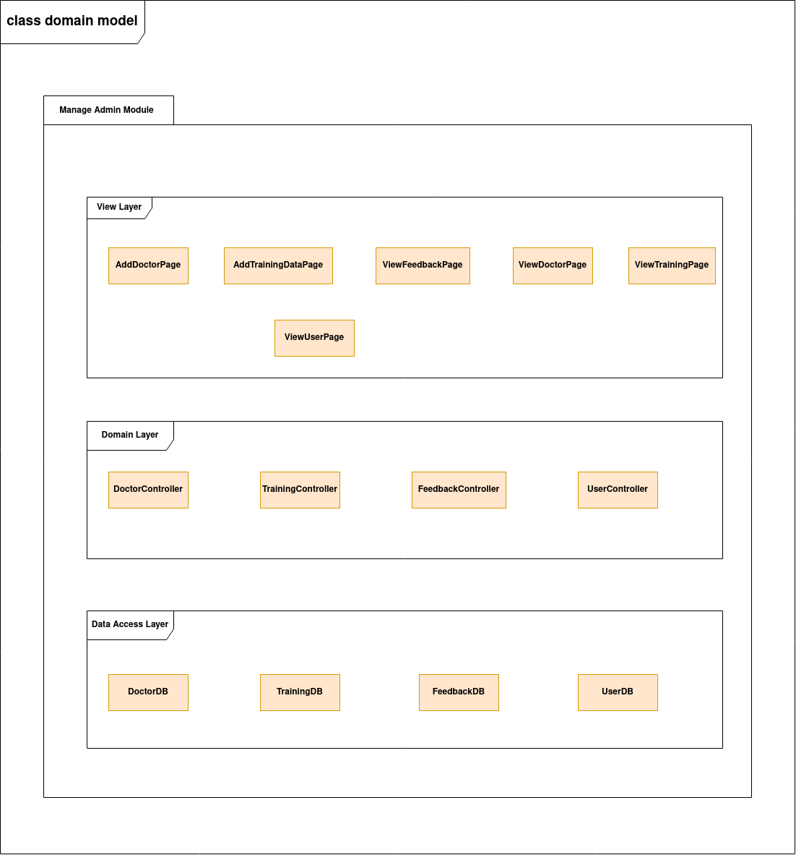
Fig 3.2. Package Diagram for Manage Admin module subsystem

3.2.1.2 Class Diagram

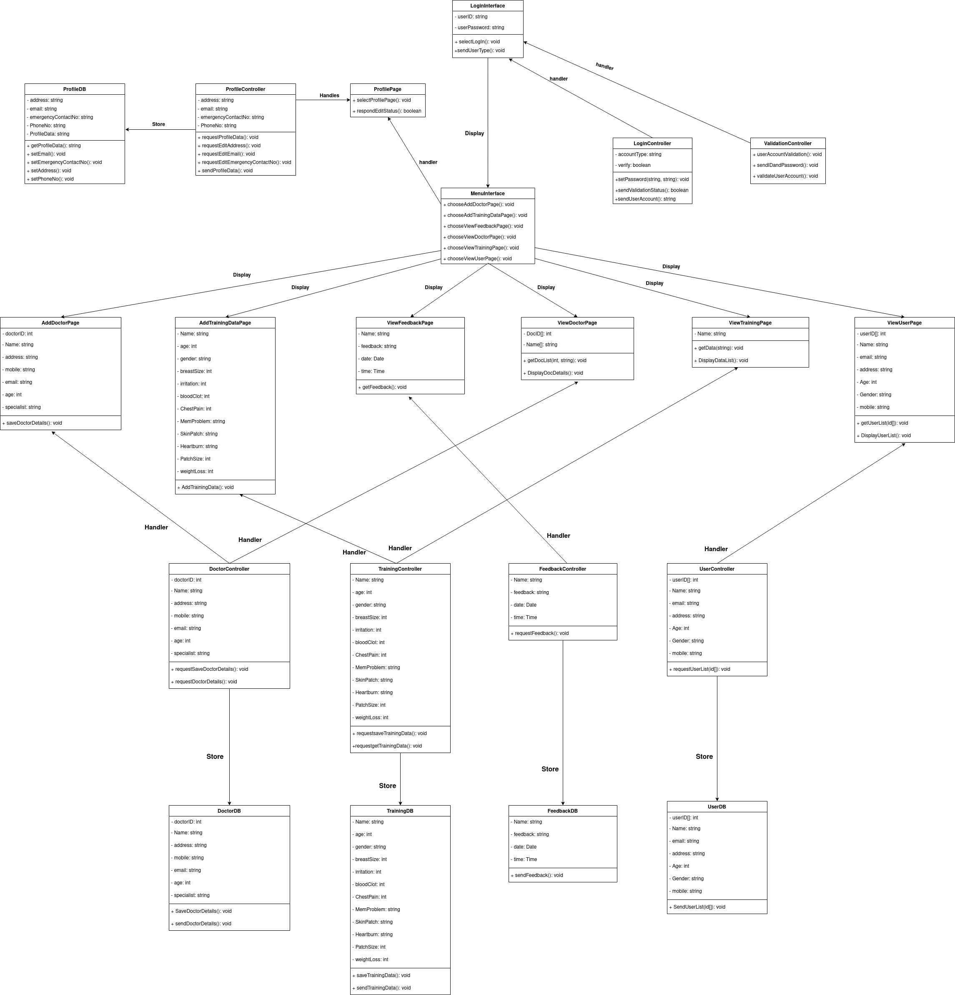
Figure 3.2: Overall Class diagram

MenuInterface
Operations
Methods | Notes | Parameters
ChooseAddDoctorPage() void public | SD001: Add Doctor Details
ChooseAddTrainingData() void public | SD002: Add Training Data
ChooseViewFeedbackPage() void public | SD003: View Feedback
ChooseViewDoctorPage() void public | SD004: View Doctor Details
ChooseViewTrainingData() void public | SD005: View Training Data
ChooseViewUserPage() void public | SD006: View User Details

AddDoctorPage
Attributes
Attribute | Constraints and tags
DoctorID int | Default:
Name string | Default:
Address string | Default:
Mobile string | Default:
Email string | Default:
Age string | Default:
Gender string | Default:
Specialist string | Default:

Operations
Methods | Notes | Parameters
SaveDoctorDetails() void public |  | DoctorID int  Name string  Address string  Mobile string  Email string  Age string  Gender string  Specialist string

DoctorController
Attributes
Attribute | Constraints and tags
DoctorID int | Default:
Name string | Default:
Address string | Default:
Mobile string | Default:
Email string | Default:
Age string | Default:
Gender string | Default:
Specialist string | Default:

Operations
Methods | Notes | Parameters
requestSaveDoctorDetails() void public | SD001 Add Doctor Details | DoctorID int  Name string  Address string  Mobile string  Email string  Age string  Gender string  Specialist string

AddTrainingData
Attributes
Attribute | Constraints and tags
Name string | Default:
Age int | Default:
Gender string | Default:
BreastSize int | Default:
Irritation string | Default:
BloodClot string | Default:
Urination string | Default:
ChestPain string | Default:
CoughBlood string | Default:
MouthPain string | Default:
RWPatch string | Default:
Chewing string | Default:
Headache string | Default:
Vomit string | Default:
MemProblem string | Default:
SkinPatch string | Default:
PatchSize string | Default:
Heartburn string | Default:
StomachBloat string | Default:
ShoulderPain string | Default:
WeightLoss string | Default:

Operations
Methods | Notes | Parameters
AddTrainingData() void public | SD002: Add Training Data | Name string  Age int  Gender string  BreastSize int  Irritation string  BloodClot string  Urination string  ChestPain string  CoughBlood string  MouthPain string  RWPatch string  Chewing string  Headache string  Vomit string  MemProblem string  SkinPatch string  PatchSize string  Heartburn string  StomachBloat string  ShoulderPain string  WeightLoss string

TrainingController
Attributes
Attribute | Constraints and tags
Name string | Default:
Age int | Default:
Gender string | Default:
BreastSize int | Default:
Irritation string | Default:
BloodClot string | Default:
Urination string | Default:
ChestPain string | Default:
CoughBlood string | Default:
MouthPain string | Default:
RWPatch string | Default:
Chewing string | Default:
Headache string | Default:
Vomit string | Default:
MemProblem string | Default:
SkinPatch string | Default:
PatchSize string | Default:
Heartburn string | Default:
StomachBloat string | Default:
ShoulderPain string | Default:
WeightLoss string | Default:

Operations
Methods | Notes | Parameters
requestSaveTrainingData() void public | SD002: Add Training Data | Name string  Age int  Gender string  BreastSize int  Irritation string  BloodClot string  Urination string  ChestPain string  CoughBlood string  MouthPain string  RWPatch string  Chewing string  Headache string  Vomit string  MemProblem string  SkinPatch string  PatchSize string  Heartburn string  StomachBloat string  ShoulderPain string  WeightLoss string
requestGetTrainingData() void public | SD005: View Training Data

ViewFeedbackPage
Attributes
Attribute | Constraints and tags
Name string | Default:
Feedback string | Default:
date Date | Default:
time Time | Default:

Operations
Methods | Notes | Parameters
getFeedback() void public | SD003: View Feedback | Name string  Feedback string  date Date  time Time

FeedbackController
Attributes
Attribute | Constraints and tags
Name string | Default:
Feedback string | Default:
date Date | Default:
time Time | Default:

Operations
Methods | Notes | Parameters
requestFeedback() void public | SD003: View Feedback | Name string  Feedback string  date Date  time Time

ViewDoctorPage
Attributes
Attribute | Constraints and tags
DocID[] string | Default:
Name string | Default:

Operations
Methods | Notes | Parameters
requestDoctorDetails() void public | SD004: View Doctor Deails | DoctorID int  Name string  Address string  Mobile string  Email string  Age string  Gender string  Specialist string

ViewTrainingPage
Attributes
Attribute | Constraints and tags
Name string | Default:

Operations
Methods | Notes | Parameters
requestData() void public | SD005: View Training Data | Name string  Age int  Gender string  BreastSize int  Irritation string  BloodClot string  Urination string  ChestPain string  CoughBlood string  MouthPain string  RWPatch string  Chewing string  Headache string  Vomit string  MemProblem string  SkinPatch string  PatchSize string  Heartburn string  StomachBloat string  ShoulderPain string  WeightLoss string

ViewUserPage
Attributes
Attribute | Constraints and tags
Id int | Default:
Name string | Default:
Address string | Default:
Mobile string | Default:
Email string | Default:
Age int | Default:
Gender string | Default:

Operations

Methods | Notes | Parameters
getUserList() void public | SD006: View User List | Id int

UserController
Attributes
Attribute | Constraints and tags
Id int | Default:
Name string | Default:
Address string | Default:
Mobile string | Default:
Email string | Default:
Age int | Default:
Gender string | Default:

Operations
Methods | Notes | Parameters
requestUserList() void public | SD006: View User List | Id int

3.2.1.3 Sequence Diagrams

a) SD001: Sequence diagram for Adding a doctor
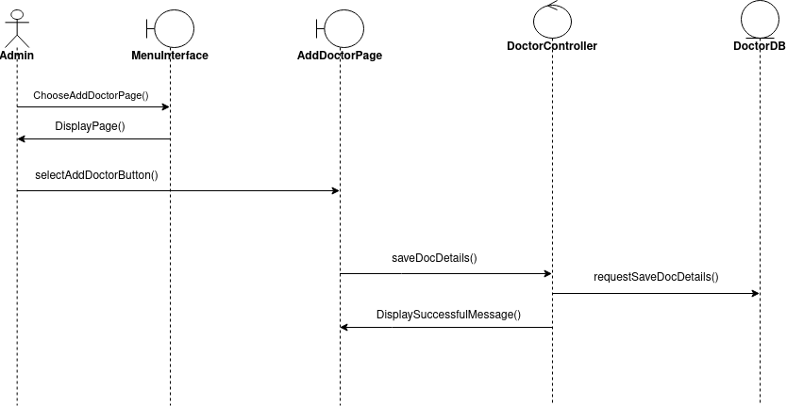
Figure 3.3: Sequence Diagram of <Add Doctor>

b) SD002: Sequence diagram for Add Training Data

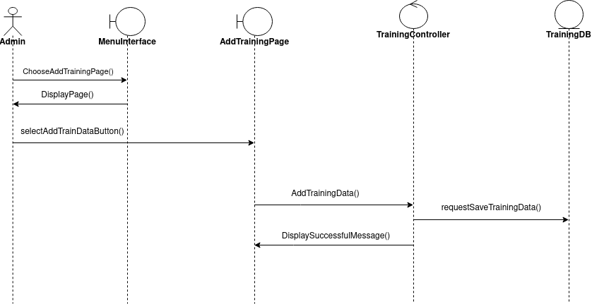
Figure 3.4: Sequence Diagram of <Add Training Data>

c) SD003: Sequence diagram for View Feedback

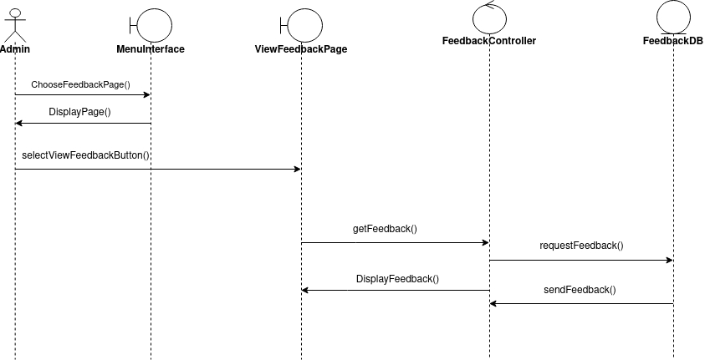
Figure 3.5: Sequence Diagram of <View Feedback>

d) SD004: Sequence diagram for View Doctor Details

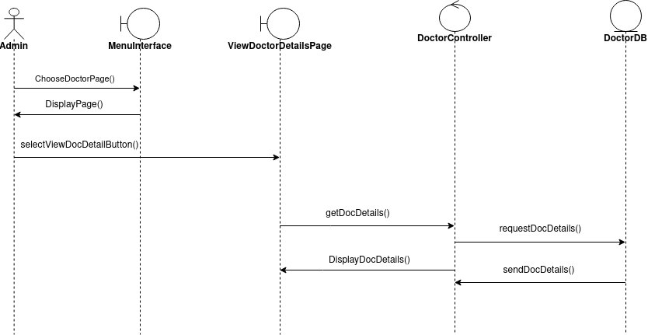
Figure 3.5: Sequence Diagram of <View Doctor Details>

e) SD005: Sequence diagram for View Training Data

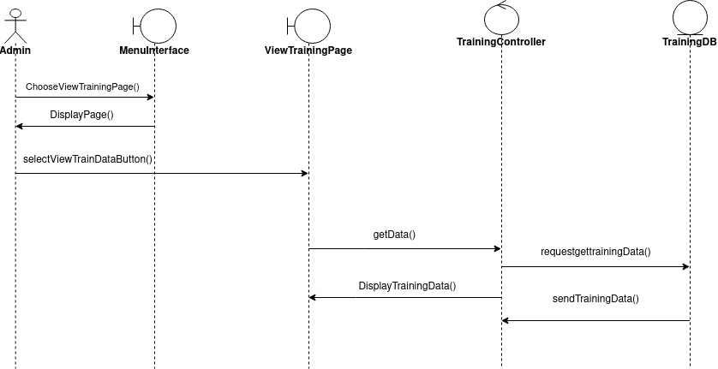
Figure 3.6: Sequence Diagram of <View Training Data>

f) SD006: Sequence diagram for View User Details

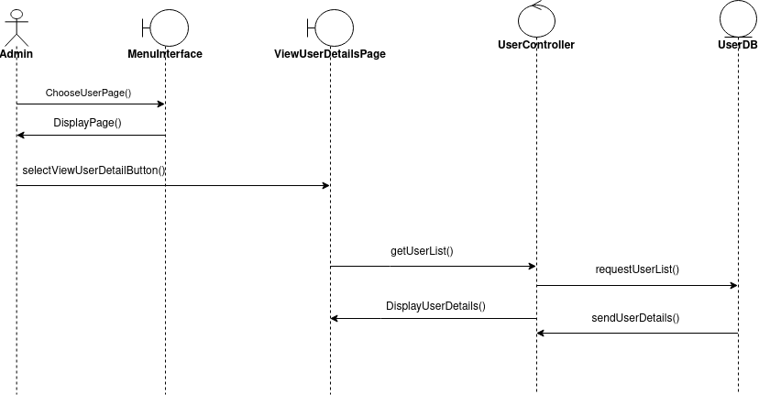
Figure 3.7: Sequence Diagram of <View user details>

4.0 Data Design

4.1 Data Description
The major data or systems entities are stored into a relational database named as “CancerPrediction” database and comprise of 4 entities (for manage admin module subsystem). The data retrieved or stored by system though the controllers from the entities or to the entities. The data is organized into attributes with the recognizable names. Each of the entities has its own contents and all of these entities have different unique name. Each of these unique names enable the system search and retrieve the data correctly when needed. Each of the entities consists its own attributes.

Entity Name | Description
DoctorDB | This entity stores all the details of the doctor that has been registered by the admin.
FeedbackDB | This entity consists of all the reviews and feedback shared by the patients and can be viewed by the admin.
TrainingDB | This entity consists of all the training data uploaded by the admin to train the machine learning model.
UserDB | This entity consist of all the details of the patients’ input for predicting the cancer type. The admin can view all this data input by the patients.

4.2 Data Dictionary

a) Entity: DoctorDB
Attributes
Attribute | Constraints and tags
DoctorID int | Default:
Name string | Default:
Address string | Default:
Mobile string | Default:
Email string | Default:
Age string | Default:
Gender string | Default:
Specialist string | Default:

Operations
Methods | Notes | Parameters
SaveDoctorDetails() void public | SD001: Add Doctor Details | DoctorID int  Name string  Address string  Mobile string  Email string  Age string  Gender string  Specialist string
SendDoctorDetails() void public | SD004: View Doctor Details | DoctorID int  Name string  Address string  Mobile string  Email string  Age string  Gender string  Specialist string

b) Entity: FeedbackDB
Attributes
Attribute | Constraints and tags
Name string | Default:
Feedback string | Default:
date Date | Default:
time Time | Default:

Operations
Methods | Notes | Parameters
sendFeedback() void public | SD003: View Feedback | Name string  Feedback string  date Date  time Time

c) Entity: TrainingDB
Attributes
Attribute | Constraints and tags
Name string | Default:
Age int | Default:
Gender string | Default:
BreastSize int | Default:
Irritation string | Default:
BloodClot string | Default:
Urination string | Default:
ChestPain string | Default:
CoughBlood string | Default:
MouthPain string | Default:
RWPatch string | Default:
Chewing string | Default:
Headache string | Default:
Vomit string | Default:
MemProblem string | Default:
SkinPatch string | Default:
PatchSize string | Default:
Heartburn string | Default:
StomachBloat string | Default:
ShoulderPain string | Default:
WeightLoss string | Default:

Operations
Methods | Notes | Parameters
saveTrainingData() void public | SD002: Add training data | Name string  Age int  Gender string  BreastSize int  Irritation string  BloodClot string  Urination string  ChestPain string  CoughBlood string  MouthPain string  RWPatch string  Chewing string  Headache string  Vomit string  MemProblem string  SkinPatch string  PatchSize string  Heartburn string  StomachBloat string  ShoulderPain string  WeightLoss string
sendTrainingData() void public | SD005: View Training Data | Name string  Age int  Gender string  BreastSize int  Irritation string  BloodClot string  Urination string  ChestPain string  CoughBlood string  MouthPain string  RWPatch string  Chewing string  Headache string  Vomit string  MemProblem string  SkinPatch string  PatchSize string  Heartburn string  StomachBloat string  ShoulderPain string  WeightLoss string

d) Entity: UserDB
Attributes
Attribute | Constraints and tags
Id int | Default:
Name string | Default:
Address string | Default:
Mobile string | Default:
Email string | Default:
Age int | Default:
Gender string | Default:

Operations
Methods | Notes | Parameters
sendUserList() void public | SD006: View User List | Id int  Name string  Address string  Mobile string  Email string  Age int  Gender string

5.0 User Interface Design

5.1 Overview of User Interface
For manage admin module subsystem, after the admin login their account, the system will display a menu that only shows functions that is relevant to the admin. For admin, the menu will show five functions such as Add training data, Add doctor details, View feedback, View User details and view training data.

For Add training data, the system will display a add new training page for the admin to upload spreadsheet files. For Add doctor details, the system will display the admin to fill up all the details and upload the resume for the doctors. After uploading, the patients can be able to see the doctors based on their predicted cancer type. For View feedback, the system will display all the reviews given by the patients. For user details, the system will display all the list of registered users. For view training data, the system will display to the admin all the list of data files uploaded.

5.2 Screen Images

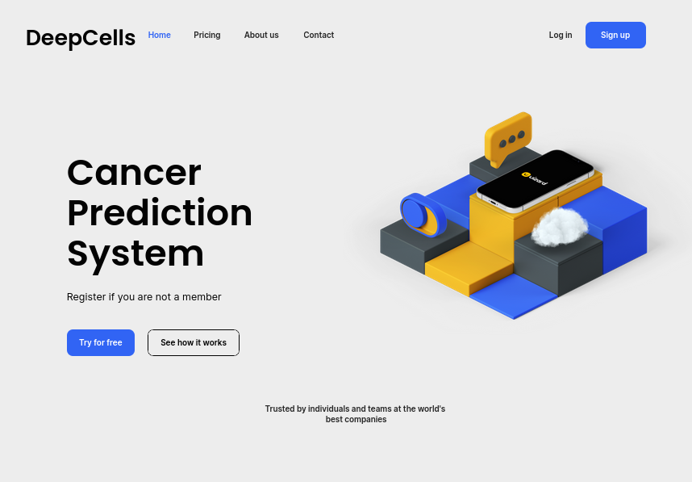

Fig 3.7. Homepage Interface

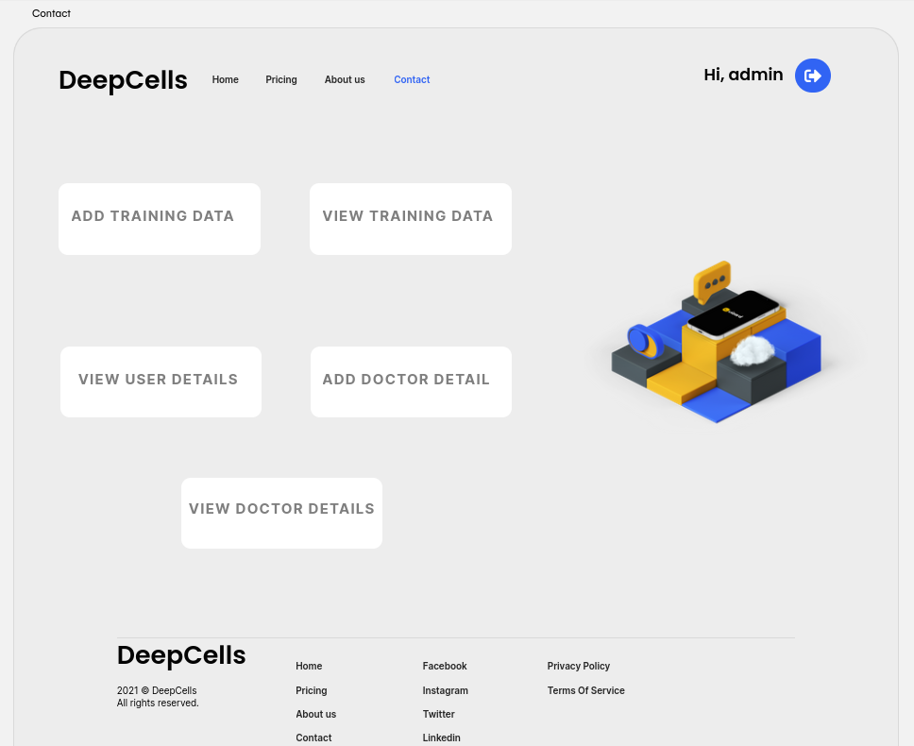
Fig 3.8. Menu Interface

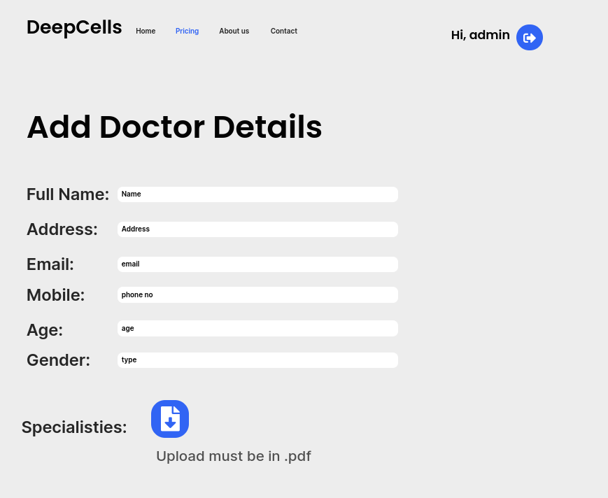
Fig 3.9. Add Doctor Details Interface

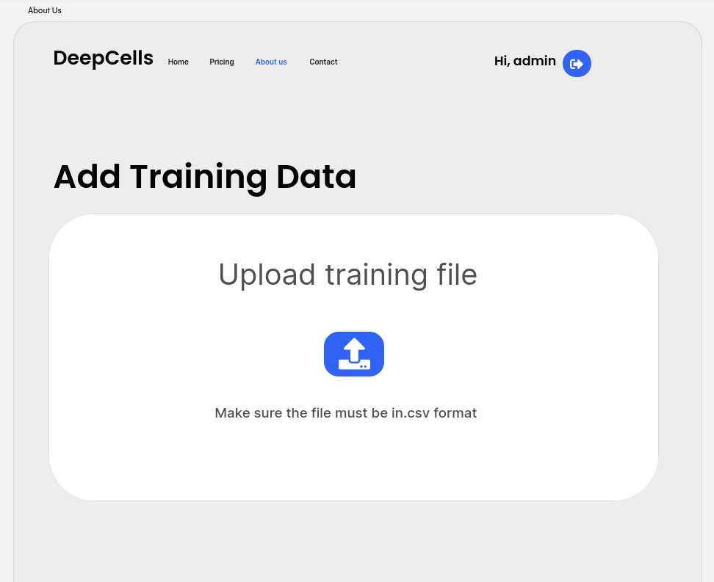
Fig 4.0. Add Training Data Interface

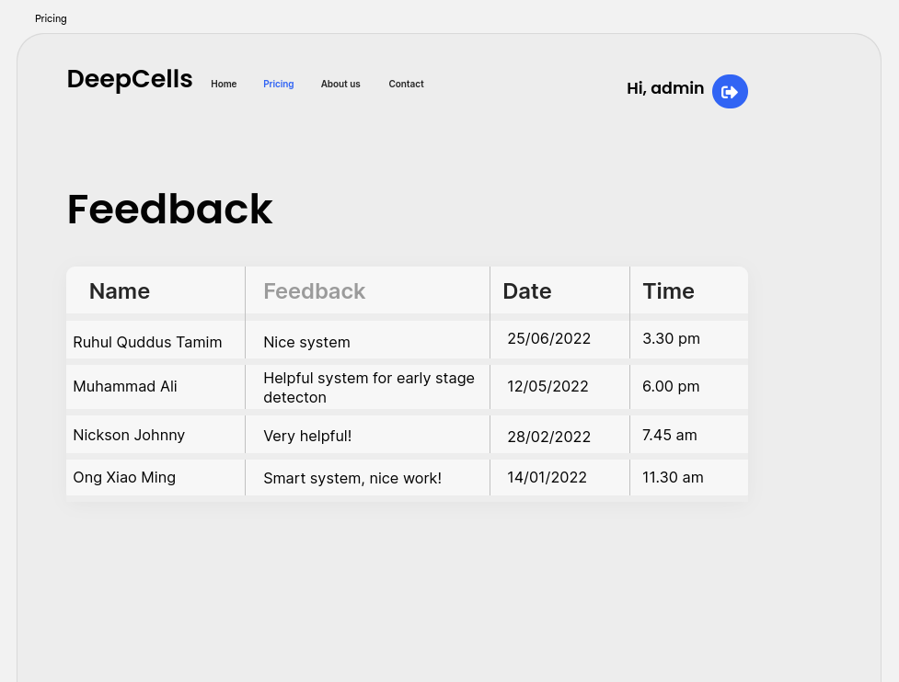
Fig 4.1. Feedback Interface

6.0 Requirements Matrix
The sequence diagrams for each use case vs. corresponding classes are as below.
 | DoctorDB | TrainingDB | FeedbackDB | UserDB
P001, UC003, SD001 | X
P001, UC004, SD001 |  | X
P001, UC005, SD002 |  |  | X
P001, UC006, SD004 | X
P001, UC007, SD005 |  | X
P001, UC008, SD006 |  |  |  | X

7.0 Appendices

N/A

